Data Structures
# Source: AI Source: Provided by: [Data Path: Persons Table -> ID Column: 1, Name_En Column: Motasem Essam] -> From: [Chatgpt (GPT‑5 Mini)] on [12/10/2025]
A Data Structure is a way of organizing, storing, and managing data in a computer so it can be used efficiently.
Data structures help programs store data, access it quickly, and modify it easily.

Why Data Structures Are Important
# Source: AI Source: Provided by: [Data Path: Persons Table -> ID Column: 1, Name_En Column: Motasem Essam] -> From: [Chatgpt (GPT‑5 Mini)] on [12/10/2025]
Data structures allow programmers to:
- Store large amounts of data
- Access data quickly
- Process data efficiently
- Organize information logically
Example:
A phone contacts list stores names and phone numbers in an organized way.

Types of Data Structures
# Source: AI Source: Provided by: [Data Path: Persons Table -> ID Column: 1, Name_En Column: Motasem Essam] -> From: [Chatgpt (GPT‑5 Mini)] on [12/10/2025]
Data structures are usually divided into two groups.

A. Linear Data Structures
# Source: AI Source: Provided by: [Data Path: Persons Table -> ID Column: 1, Name_En Column: Motasem Essam] -> From: [Chatgpt (GPT‑5 Mini)] on [12/10/2025]
Data elements are arranged sequentially (one after another).
Examples:
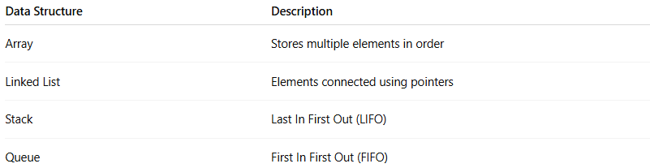
Data Structure | Description
Array | Stores multiple elements in order
Linked List | Elements connected using pointers
Stack | Last In First Out (LIFO)
Queue | First In First Out (FIFO)
Example of an array:
[10, 20, 30, 40]

B. Non-Linear Data Structures
# Source: AI Source: Provided by: [Data Path: Persons Table -> ID Column: 1, Name_En Column: Motasem Essam] -> From: [Chatgpt (GPT‑5 Mini)] on [12/10/2025]
Data elements are not stored sequentially.
Examples:
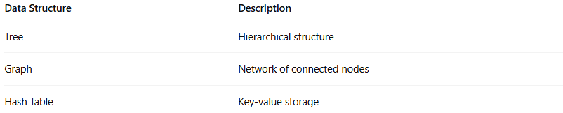
Data Structure | Description
Tree | Hierarchical structure
Graph | Network of connected nodes
Hash Table | Key-value storage
Example tree structure:
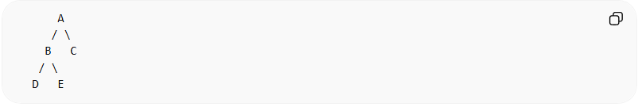
A
/ \
B C
/ \
D E

Common Data Structures
# Source: AI Source: Provided by: [Data Path: Persons Table -> ID Column: 1, Name_En Column: Motasem Essam] -> From: [Chatgpt (GPT‑5 Mini)] on [12/10/2025]
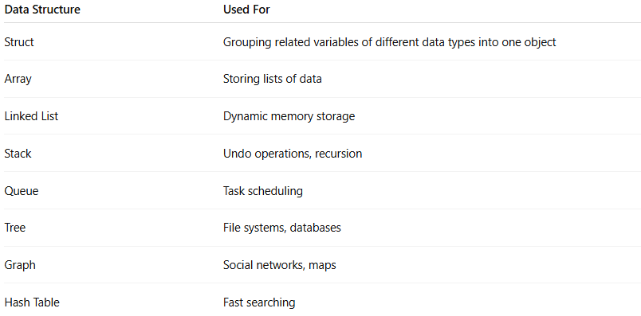
Data Structure | Used For
Struct | Grouping related variables of different data types into one object
Array | Storing lists of data
Linked List | Dynamic memory storage
Stack | Undo operations, recursion
Queue | Task scheduling
Tree | File systems, databases
Graph | Social networks, maps
Hash Table | Fast searching

Real-World Examples
# Source: AI Source: Provided by: [Data Path: Persons Table -> ID Column: 1, Name_En Column: Motasem Essam] -> From: [Chatgpt (GPT‑5 Mini)] on [12/10/2025]
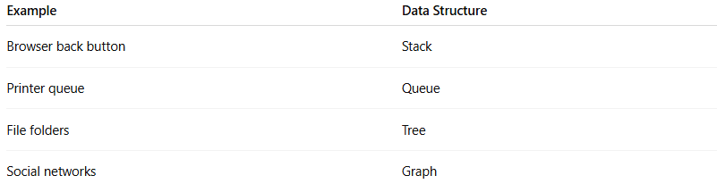
Example | Data Structure
Browser back button | Stack
Printer queue | Queue
File folders | Tree
Social networks | Graph

✔ In simple terms:
# Source: AI Source: Provided by: [Data Path: Persons Table -> ID Column: 1, Name_En Column: Motasem Essam] -> From: [Chatgpt (GPT‑5 Mini)] on [12/10/2025]
A data type defines what kind of data you store, while a data structure defines how the data is organized.

💡 Memory Structure Tip:
# Source: AI Source: Provided by: [Data Path: Persons Table -> ID Column: 1, Name_En Column: Motasem Essam] -> From: [Chatgpt (GPT‑5 Mini)] on [12/10/2025]
- Think of stack like a stack of plates:
  - You can only remove or add the top plate.
- Array stack: boxes in contiguous memory
- Linked list stack: nodes linked, top points to last pushed

